**Marathwada Mitra mandal’s**

# COLLEGE OF ENGINEERING

**Karvenagar, Pune**

## An Autonomous Institute

**Presentation**

**On**

USER-FRIENDLY & IMPACTFUL ACADEMIC ENVIRONMENT

# EEL VSC PROJECT

|  |  |  |
| --- | --- | --- |
| Sr.No | Prn No | Name of students |
| 1 | B24IT1083 | RADHIKA SURYATAL |
| 2 | B24IT1081 | RUTUJA GHODEKAR |
| 3 | B24IT1100 | SAI MALI |
| 4 | B24IT1063 | SANKET GHODAKE |

**Outline:**

1. **Introduction**
2. **Research**
3. **Analysis**
4. **Ideate**
5. **Build**
6. **Test**

**VII. Implement**

**VIII.Reference**

**A. Introduction**

* **Purpose**:
  + - To create a user-friendly &impactful academic environment through visual & graphical demonstration.
* **Overview**:
  + - The project focuses on re-envisioning learning methodologies to move away from rote memorization.
* **Key Themes**:
  + - Interactive Learning: Engaging students with animated lessons and gamified activities.
    - Customization: Providing educators with tools to tailor lessons to their specific requirements.

**B. Research**



* The primary objective of the research phase was to understand the challenges in traditional academic environments and identify opportunities for innovation.



* A detailed analysis of current trends revealed a significant shift from rote learning to interactive, technology-driven teaching methods. Students expressed a strong preference for visual and gamified learning experiences, while teachers highlighted the need for easy-to-use and customizable digital tools. Research into existing technologies emphasized the potential of C programming libraries, such as graphics.h and OpenGL, for creating animations and simulations.
* The research concluded that visual and interactive content is highly effective, and there is a pressing need for affordable, adaptable tools to enhance teaching and learning experiences.



**C. Analysis**

* The analysis phase focused on translating research findings into actionable insights. It identified key challenges, including the lack of technical expertise among teachers, the high cost of existing digital learning tools, and the limited customization options in current solutions.
* Despite these challenges, the analysis revealed significant opportunities to improve academic environments. One major opportunity is the development of affordable, programming-based tools that utilize C libraries for creating animations and simulations.
* These tools can empower educators by providing reusable templates that simplify content creation. Another opportunity lies in gamifying the learning experience through features like interactive quizzes, progress tracking, and visual storytelling. By synthesizing these findings, the analysis outlined a clear strategy for creating user-friendly and cost-effective solutions that make learning more engaging and impactful for both students and educators

D. Ideate

* The ideation phase focused on generating innovative solutions to address the challenges identified during the research and analysis phases. A variety of brainstorming techniques were employed, involving collaboration with educators, students, and developers to explore features that could enhance teaching and learning.
* Key ideas included gamified lessons that reward students with points and badges for their progress, as well as interactive animations to simplify complex concepts in subjects like physics, chemistry, and computer science.
* Creative techniques, such as mind mapping, helped to visualize and refine potential features, including pre-built templates for animations and interactive exercises. The most promising idea was the development of a C programming library equipped with modules for creating engaging animations, graphical visualizations, and string-based exercises.
* This tool aims to provide educators with an easy-to-use solution that requires minimal technical expertise while fostering creativity and engagement in the classroom.

**E. Build**

* The build phase focused on turning ideas into tangible solutions through the creation of prototypes and functional models. The process began with soft prototyping, which involved designing wireframes and mockups for the tool’s user interface.
* These designs illustrated how educators would interact with the tool to create visual lessons, animations, and interactive exercises. Storyboards were also developed to demonstrate the flow of lessons and user interactions, ensuring the solution aligned with educational goals.
* The next step was hard prototyping, where the actual coding and development took place. Using C programming libraries such as graphics.h and OpenGL, developers created animations and graphical demonstrations for use cases like sorting algorithms, chemical reactions, and planetary motion.
* Additional features, such as interactive quizzes and progress-tracking modules, were also built and integrated into the platform. This phase ensured the creation of a minimum viable product (MVP) that combined the core functionalities of visual learning, interactivity, and gamification. By focusing on both the design and functionality, the build phase laid the foundation for an impactful and user-friendly educational tool.

**F.Test**

* The testing phase was crucial for refining the solution to ensure it met the needs of both educators and students. The process began with usability testing, where teachers evaluated the tool to confirm that it was intuitive and easy to use, even for those with minimal technical expertise.
* This was followed by beta testing, in which the prototype was introduced in real classroom settings to gather feedback from students and educators on its effectiveness and engagement. Additionally, performance testing was conducted to ensure the tool’s animations and interactive features ran smoothly across different devices and hardware setups.Feedback collected during testing highlighted key areas for improvement, such as expanding the tool’s functionality to support multi-language content and adding more customizable templates for educators.
* Based on this feedback, an iterative design approach was adopted to make continuous refinements. Bugs were resolved, features were enhanced, and new elements were introduced to improve usability and engagement.
* This cycle of testing and iteration ensured that the final product was polished, impactful, and aligned with the needs of its users, creating a reliable and innovative solution for modern education.

**G.Implementation:**

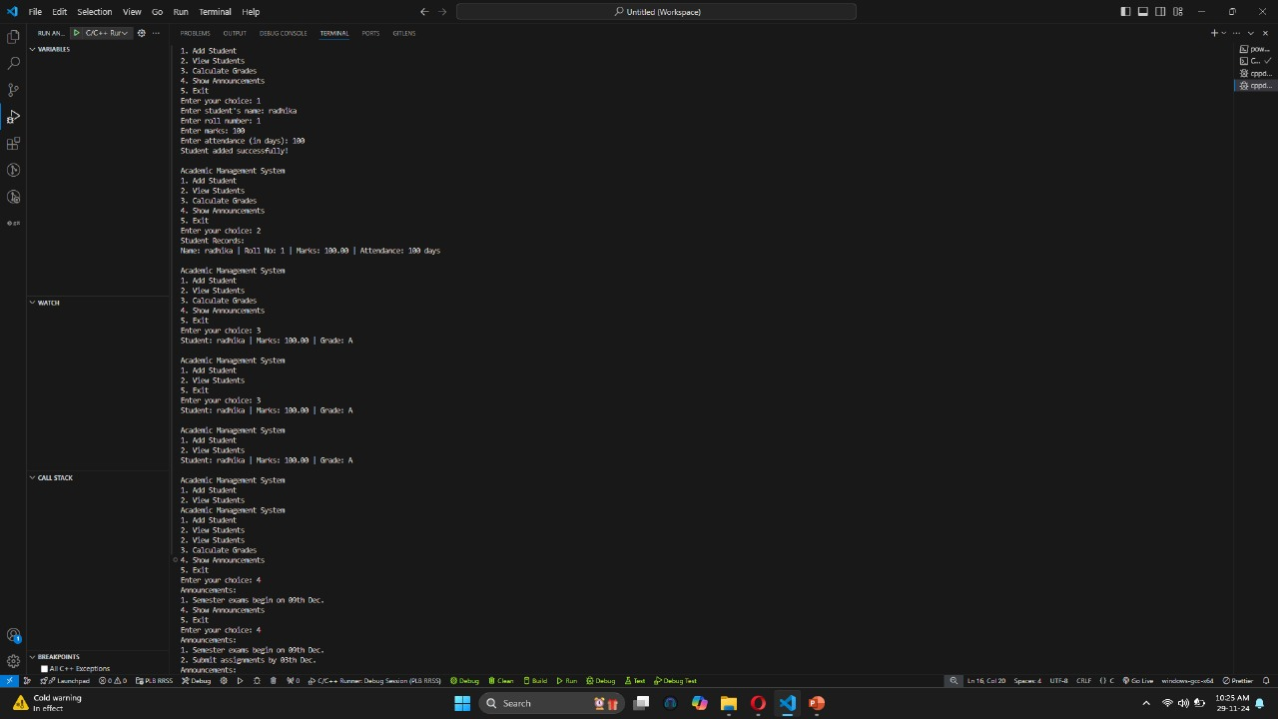 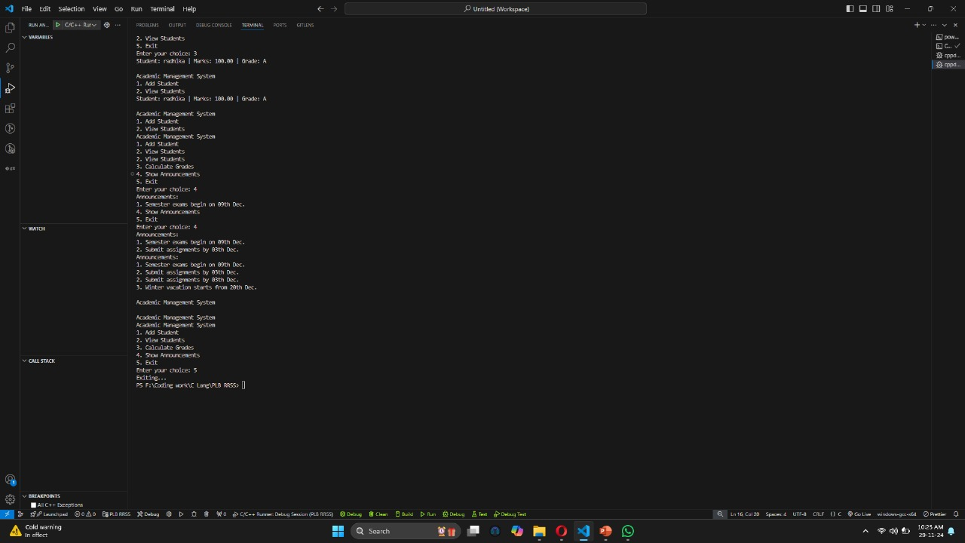

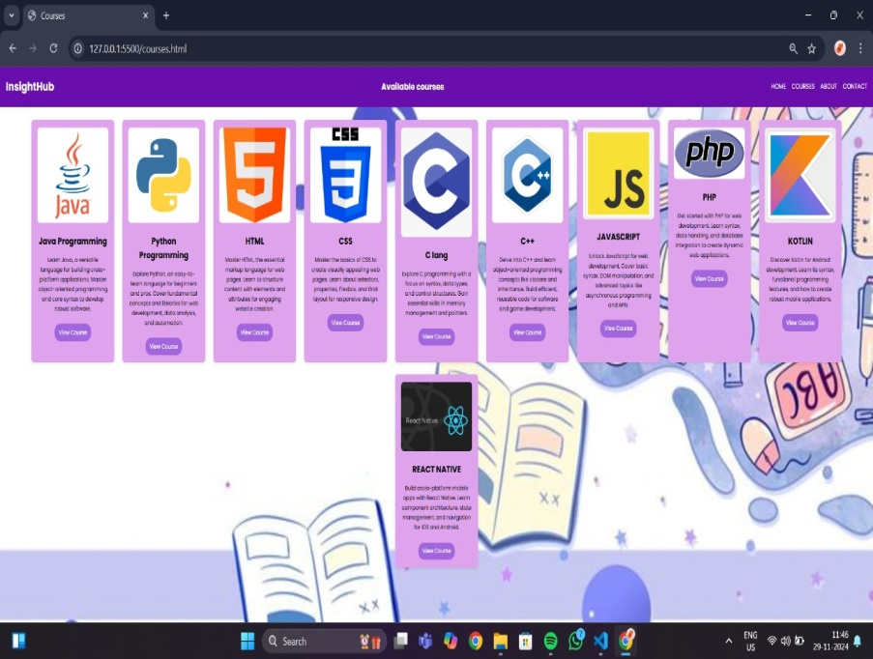 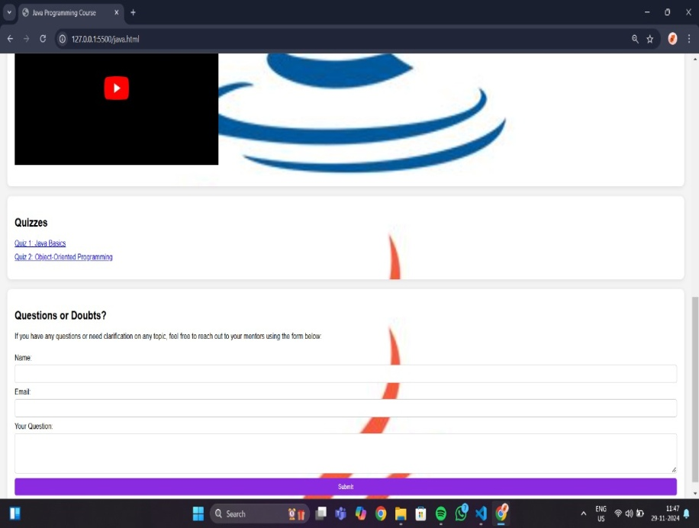

**G.Reference**

**Textbooks:**

* *Programming in C* by Dennis Ritchie for foundational concepts.
* *Data Structures and Algorithm Analysis in C* by Mark Allen Weiss for efficient data handling.

**Online Resources:**

* GeeksforGeeks: [GeeksforGeeks | A computer science portal for geeks](https://www.geeksforgeeks.org/)
* Stack Overflow: <https://stackoverflow.com/>

* ChatGPT

**Documentation Tools:**

* Visual Studio Code for code editing and testing.